
React Assignment 2
Submitted to: Sir Ubaidullah

29 March 2025
Muhammad Arham Hussain Khan
22K-4080

Hosted Link: https://graybookstore.netlify.app/
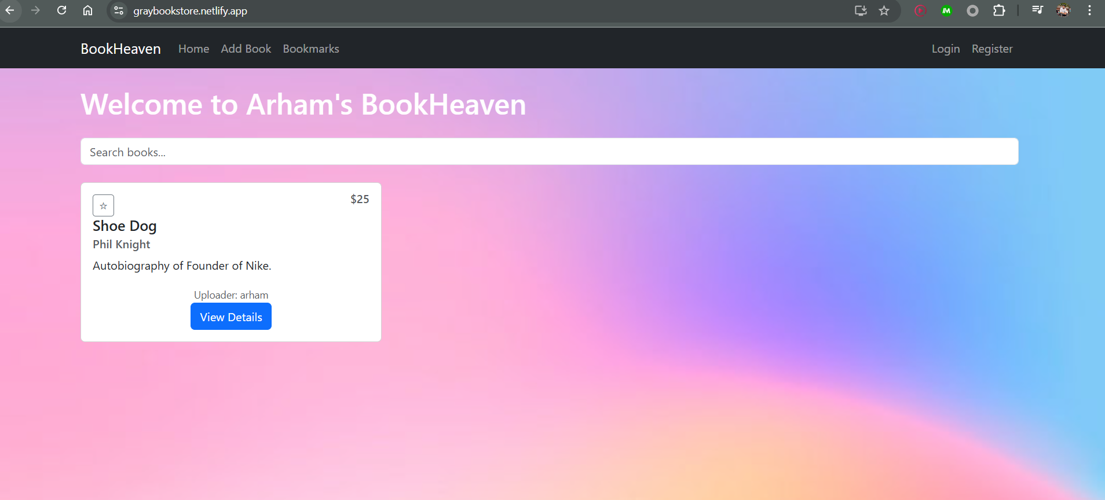
Technology Stack:
- React.js (Functional Components, Hooks)
- React Router v6 (Routing)
- React Bootstrap (Styling) – used custom CSS for fixing background image only.
- Context API (State Management)
- LocalStorage (Data Persistence)

Fulfilled all the Required Functionality
- Homepage with Search Functionality
- Implementation:
  - BookList.js component displays all books in a responsive grid.
  - Search bar filters books by title/author (case-insensitive).
  - Bootstrap Components: Card, Row, Col, Form.Control.
  - Location: components/books/BookList.js.

- Book Detail Page with Reviews
- Implementation:
  - Dynamic routing (/book/:id) in BookDetail.js.
  - Displays book metadata, reviews, and a "Write Review" button.
  - Reviews show author name (or "Anonymous"), feedback (👍/👎), date, and text.
  - Location: components/books/BookDetail.js.
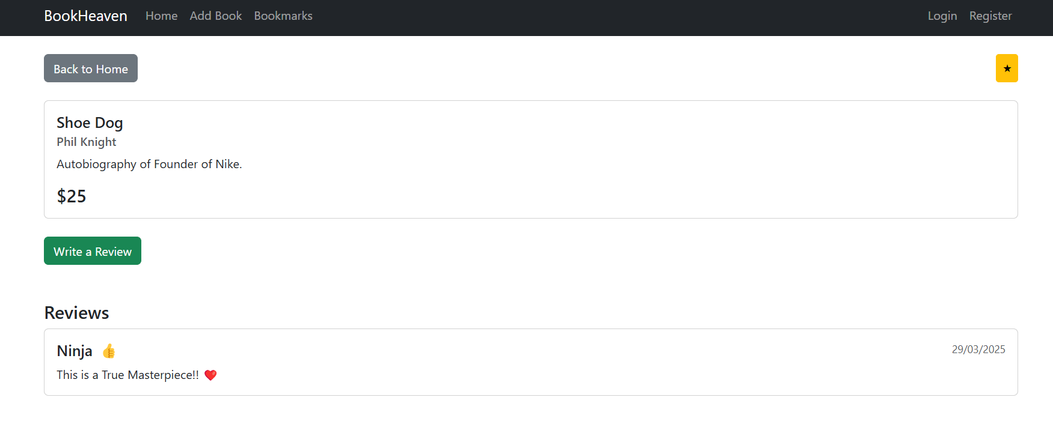

3) New Book Form (with Validation)
- Implementation:
  - AddBookForm.js includes validation for required fields and duplicate titles.
  - Validation Rules:
    - All fields required.
    - Price must be a positive number.
    - Title must be unique (case-insensitive comparison).
  - Only authenticated users can access (/add-book route).
  - Location: components/books/AddBookForm.js.
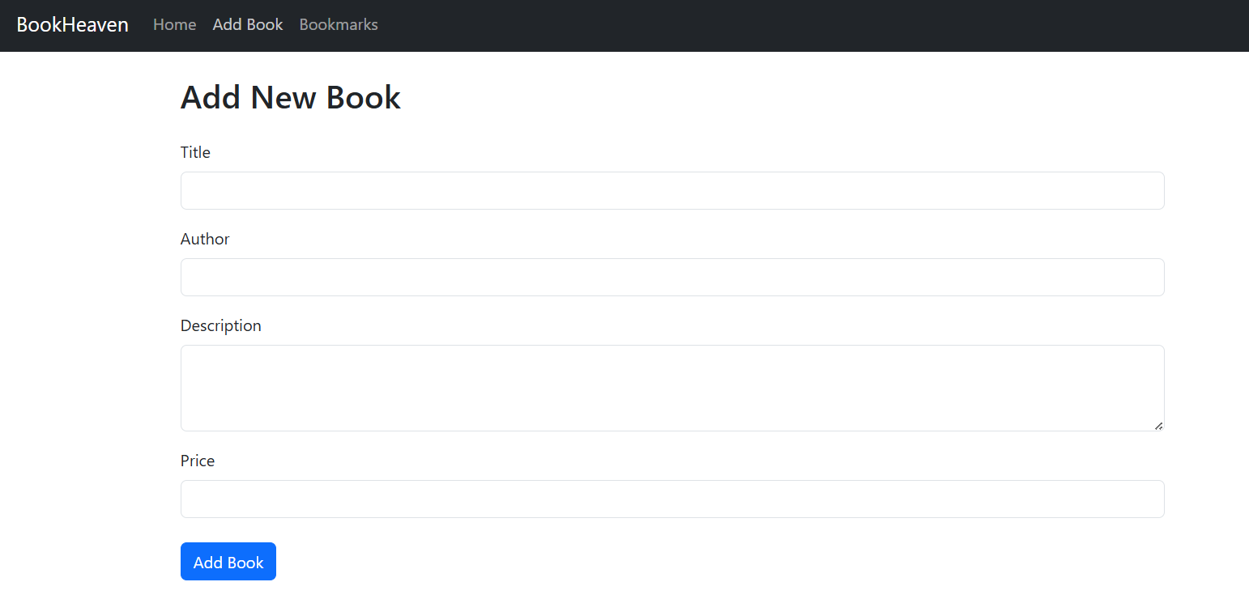
4) Nested Routing
- Implementation:
  - Review submission uses nested routing (/book/:id/submit-review).
  - Modal-like popup form (SubmitReviewForm.js) for submitting reviews.
  - Features:
    - Option to post anonymously.
    - Thumbs Up/Down feedback selection.
  - Location: components/reviews/SubmitReviewForm.js.
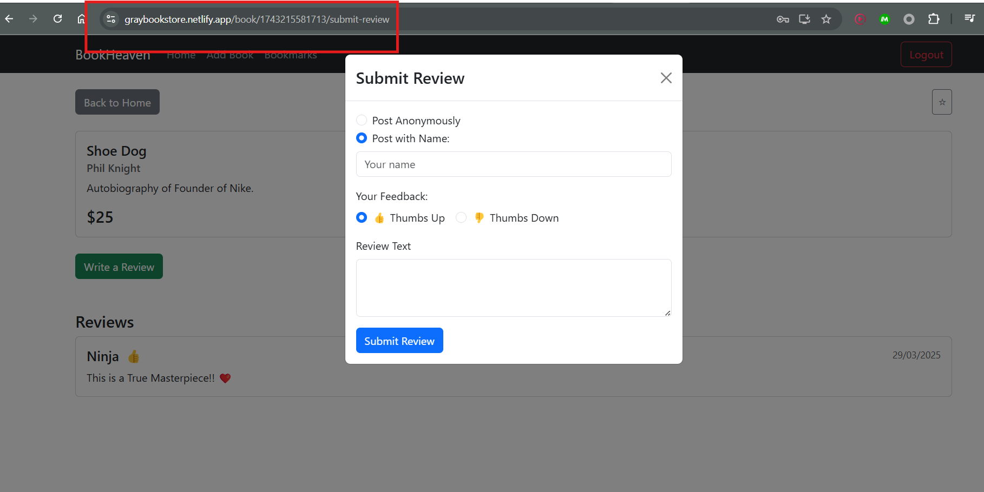

5) State Management with React Hooks
- Context Providers:
    - AuthContext.js: Manages user authentication state.
    - BookContext.js: Manages books, reviews, and favorites.
  - Hooks Used: useState, useEffect, useContext, useParams, useNavigate.

6) User Authentication System
- Implementation:
  - Registration (Register.js) and Login (Login.js) pages.
  - Features:
    - Session maintained using localStorage.
    - Unique username validation during registration.
    - Protected routes (e.g., only logged-in users can add books).
  - Location: components/auth/Login.js and components/auth/Register.js.

7) Favorites Feature with Persistence
- Implementation:
  - Users can mark books as favorites using the FavoriteButton.js.
  - Favorites page (BookmarksPage.js) displays all favorited books.
  - Persisted in localStorage via BookContext.js.
  - Location: components/books/BookmarksPage.js.
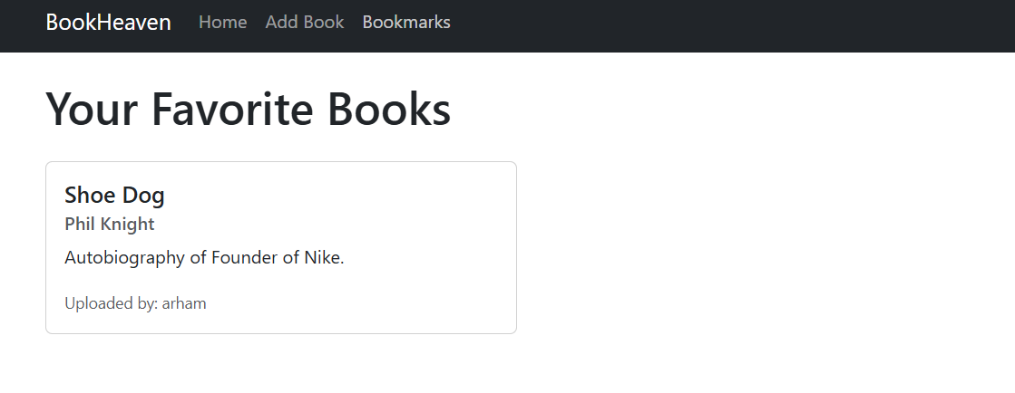

Additional Features
- Delete Book Functionality:
  - Only the uploader can delete their books (visible via Delete button in BookList.js).
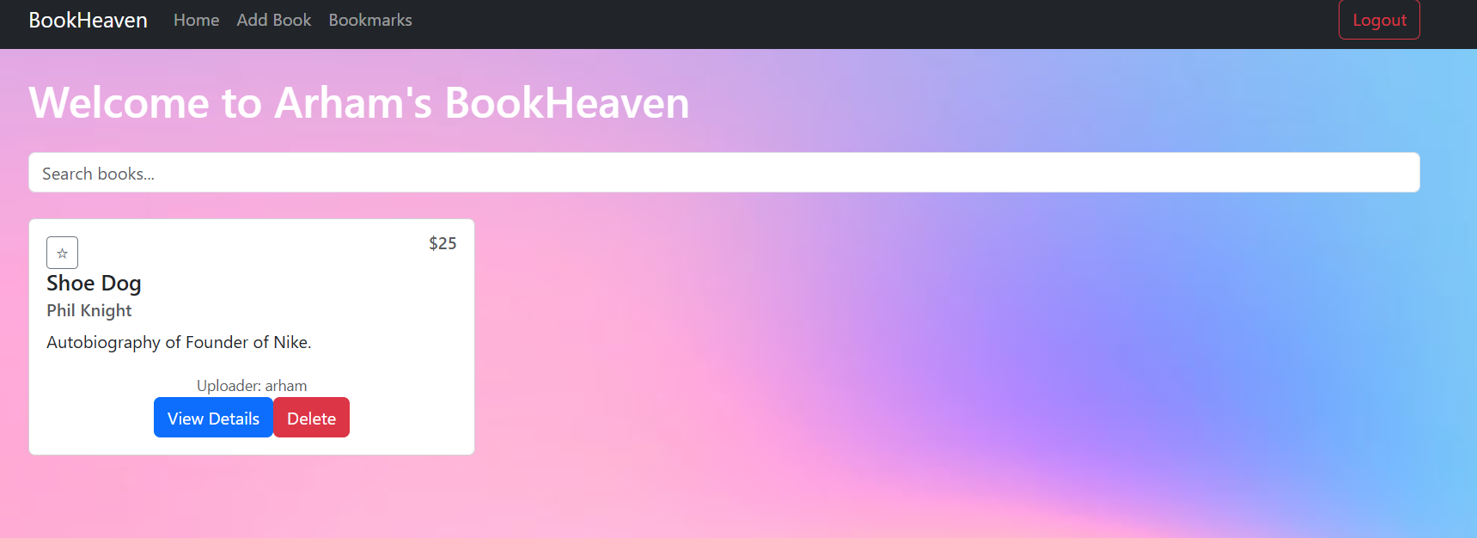

- Anonymous Reviews:
  - Users can choose to post reviews anonymously.
- Uploader Attribution:
  - Book cards display the uploader’s name in small text.

Technical Implementation Details
State Management
- AuthContext: Handles user authentication state and registration logic.
- BookContext: Manages:
  - Books data (CRUD operations).
  - Favorites list.
  - Reviews system.

4. Testing & Validation
- Authentication Flow:
  - Users must register first.
  - Login rejects invalid credentials.
  - Logout clears session.
- Form Validation:
  - Add Book form blocks duplicates.
  - Review form requires text input.
- Authorization:
  - Delete button only visible to the uploader.
  - /add-book redirects to login if unauthenticated.

Challenges & Solutions
- Form Validation:
  - Issue: Duplicate title validation required cross-component state access.
  - Solution: Used BookContext to access existing books data.
- Nested Routing:
  - Issue: Implementing a modal-like review form without disrupting parent route.
  - Solution: Used React Router’s nested routes with <Outlet>.
- State Persistence:
  - Issue: Data loss on page refresh.
  - Solution: Stored state in localStorage with useEffect.

Improvements that can be added
- Editing Existing Books functionality.
- Implement pagination for large book lists.
- Add user profiles and review editing.
- Enhance search with filters (price, genre).

